23 NYCRR 500 Compliance for Log360 Cloud
Automate 23 NYCRR 500 compliance and fortify cybersecurity resilience for financial institutions with Log360.
Region: USA | Type: Financial Services, Incident Management | Category: Compliance | Pricing: Free

Overview
The 23 NYCRR 500 compliance extension in Log360 helps organizations meet 23 NYCRR Part 500, the cybersecurity regulation issued by the New York State Department of Financial Services (NYDFS) for financial services companies by providing centralized log management, real-time threat detection, and compliance-focused reporting. The platform supports 23 NYCRR 500 requirements for access controls, audit trail retention, multi-factor authentication, encryption monitoring, vulnerability assessment, incident response within 72 hours, and third-party risk oversight across cloud and on-premise environments.
For Cybersecurity Program and Governance, Log360 provides centralized monitoring dashboards supporting program oversight and governance reporting to senior leadership. To address Access Privilege Management and Least Privilege, the platform monitors logon events, tracks privilege changes, and generates access review reports across Active Directory, Windows, Unix, and cloud environments. The extension also supports Multi-Factor Authentication Enforcement by providing capabilities that monitors MFA logon events across Entra ID, cloud applications, and backup systems to verify MFA enforcement and detect bypass attempts.

Key Features
- Audit Trail for Financial Transactions and Events: Log360 provides centralized log collection, tamper-proof storage, and long-term retention capabilities.
- Centralized Logging and Security Event Alerting: Log360 serves as the central SIEM aggregating logs from all systems, providing real-time correlation, alerting on security events, and maintaining comprehensive event records.
- Vulnerability Governance and Attack Surface Monitoring: Log360 centralizes vulnerability assessment results across hybrid environments, enabling security teams to prioritize remediation efforts based on asset criticality and track vulnerability trends to strengthen the organization's defensive posture.
- Monitoring for Unauthorized Access and Malicious Code: Log360 provides real-time anomaly detection, malware event correlation, and web traffic monitoring across all platforms.

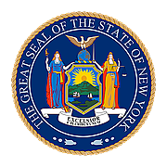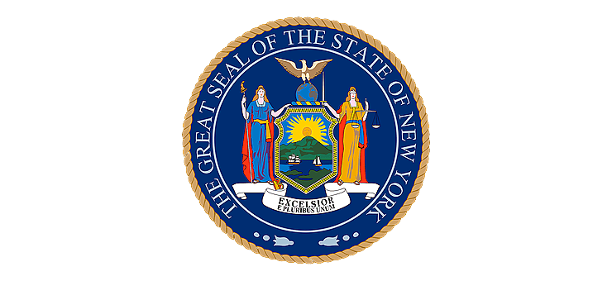
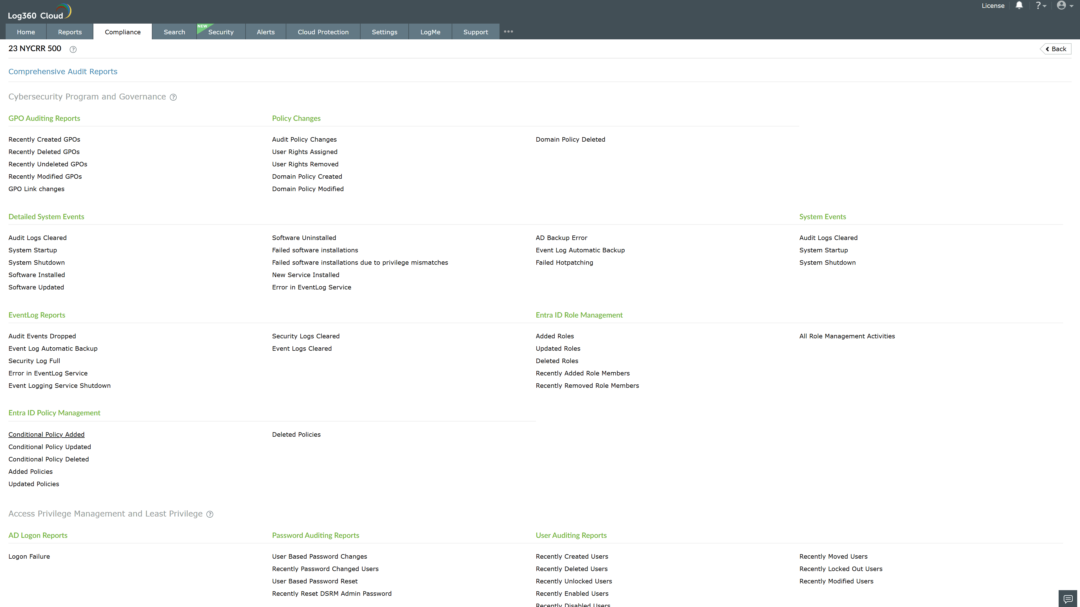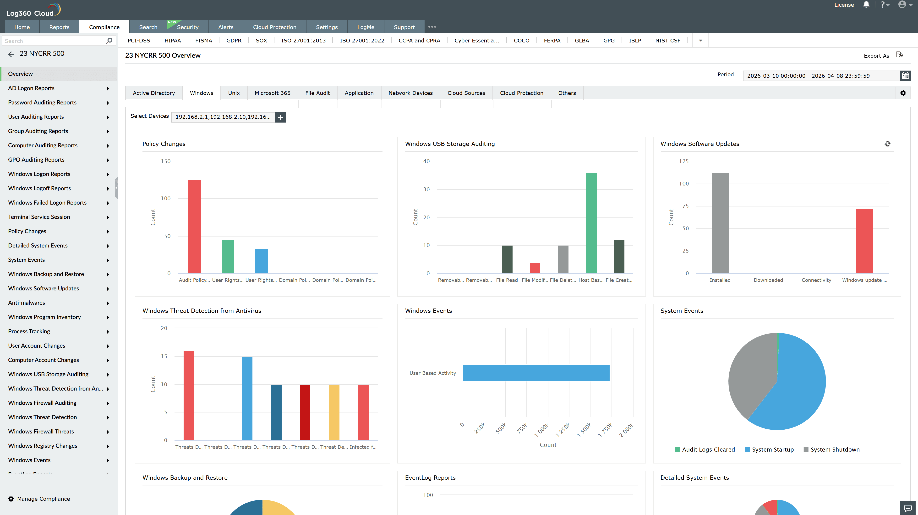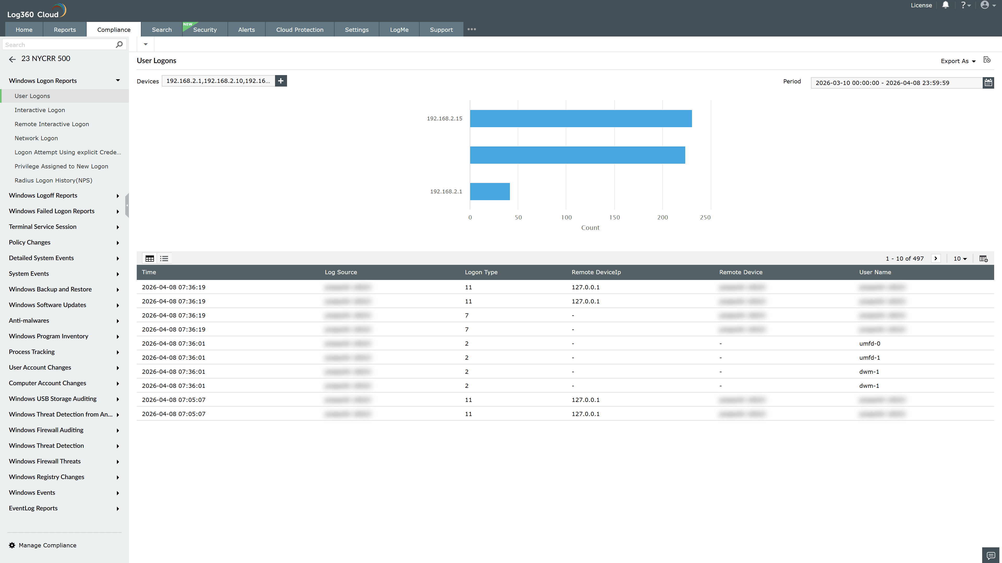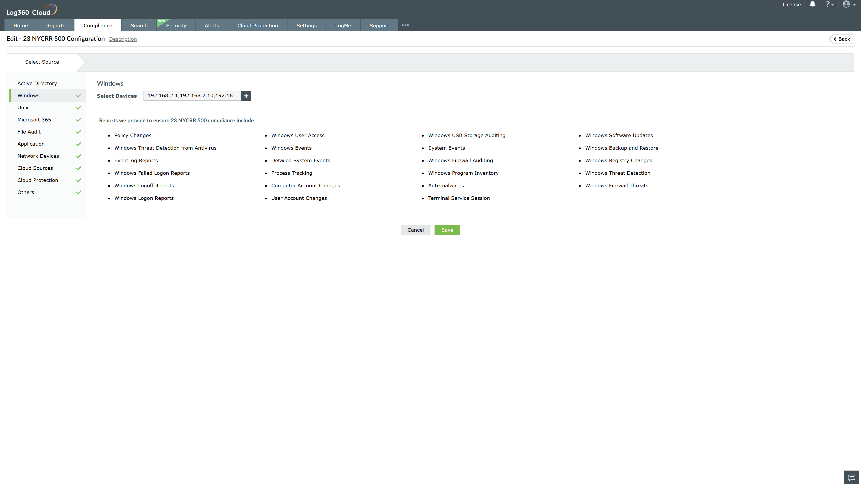
Valid Submission : Yes
Supported Editions : Free, Basic, Standard, Professional, MSSP
Help Document : https://www.manageengine.com/log-management/help/integrations/compliance-extensions.html
Help Video : Not provided
Tags : Log360, Compliance, Privacy monitoring, Data privacy, Regulatory compliance
Supported DCs : US, IN, JP, CA, AU, UK and EU
Privacy Policy:
Terms of Service:
Release Notes:
Predefined reports for the 23 NYCRR 500.

